6 Parachute Challenges

By Dr. John Byl

Follow/Subscribe with John on Twitter, Instagram, Pinterest, YouTube, or on his website

- Big Ball Roll
https://www.canadago4sport.com/Leadership/Big-Ball-Roll

Objective:
- To determine how many times a ball can successfully rolled around on a parachute in a specified time
- https://youtu.be/NeOL09PoR2U

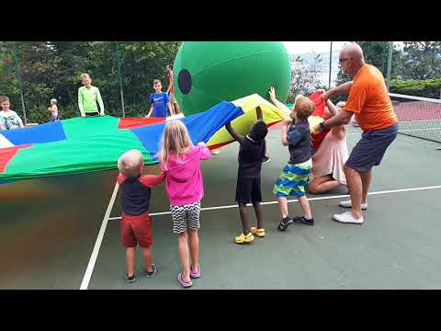

Fundamental Movement Skills:
- Non-Locomotor
  - Pull​

Equipment List:
- One large parachute
- One large ball

Setting Up:
- Players stand holding a parachute in a tight position.
- Place a large ball onto the parachute.

Instructions:
- On the leader's signal to begin players attempt to roll the ball around the parachute as often as possible within a specified time period.

Notes and Questions for Understanding:
- Variation:
  - Go 30 seconds in one direction and then 30 seconds in the opposite direction. ​
- Question for Understanding: ​
  - What ​type of movement improves success?
  - What type of leadership improves success?

- Pop the Big Ball
https://www.canadago4sport.com/Leadership/Pop-the-Big-Ball

Objective:
- For groups of players to determine how high they can launch a big ball off a parachute
- https://youtu.be/ShKYo68ArZ4

Fundamental Movement Skills:
- Non-locomotor
  - Pull​

Equipment List:
- One large parachute
- One large ball

Setting Up:
- Players stand holding a parachute in a tight position.
- Place a large ball onto the parachute.

Instructions:
- When the team is ready the let the huge ball down a little, tighten the parachute to launch the big ball as high as possible.
- Try again.

Notes and Questions for Understanding:
- Questions for Understanding:
  - What helps a team to launch the ball the highest? ​
  - How does teamwork help in launching the ball higher?

Turtle

https://www.canadago4sport.com/Locomotor/Turtle

Objective:
- For groups to cover themselves with a parachute and wiggle their way to a destination line.
- https://youtu.be/_oZzxhTkQMk

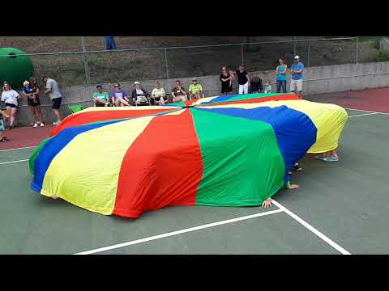

Fundamental Movement Skills:
- Locomotor
  - Wiggle

Equipment List:
- One large parachute

Setting Up:
- Players stand in a circle holding an outstretched parachute.
- Establish a destination line--maybe five paces away.

Instructions:
- Players lift the parachute aloft and then pull the parachute beneath their seats as they sit on the edge of the parachute.
- Players then attempt to wiggle the entire group to the destination line.

Notes and Questions for Understanding:
- Questions for Understanding:
  - What is helpful for a team to succeed at this task?

- Heads In
https://www.canadago4sport.com/Leadership/Head%27s-in

Objective:
- To lift a parachute, have players lay down and pull the parachute over their shoulders so only their heads are facing in.
- https://youtu.be/L-xX5Y94WwQ

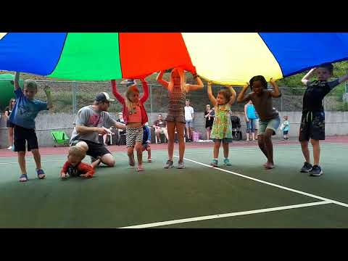

Fundamental Movement Skills:
- Non-Locomotor
  - Pull​

Equipment List:
- One large parachute

Setting Up:
- Players stand holding a parachute in a tight position.

Instructions:
- On the leader's signal to begin, players lift the parachute aloft, lie down, and pull the parachute over their shoulders so only their heads are facing in.

Notes and Questions for Understanding:
- This is a fun time to have the leader explain something as long as the parachute stays aloft.

- Mushroom Switch Identities Under
https://www.canadago4sport.com/Leadership/Mushroom-Switch-Identities-Under

Objective:
- To switch under the parachute when an identifying characteristic is true for you
- https://youtu.be/jUYButsG0Qs

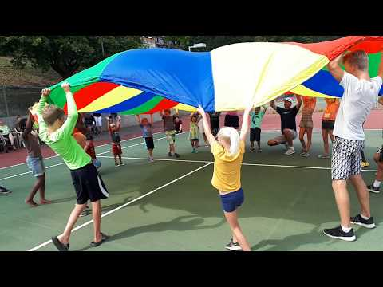

Fundamental Movement Skills:
- Locomotor​
  - Run

Equipment List:
- One Parachute

Setting Up:
- Players stand in a circle each holding the edge of a parachute.

Instructions:
- The leader identifies a characteristic--For example, players with:
  - First names beginning with A, B, C, or D.
  - A pet at home.
  - Blue eyes.
  - Born in September.
  - Have three siblings.
  - Live on an avenue...
- On the leader's command to raise the parachute, all players raise the parachute, and those who match the identified characteristics release the parachute and switch places with those who have a similar characteristic.

Notes and Questions for Understanding:
- Question for understanding:
  - Who had similar characteristic X with you?

- Unforeseen Volleyball

https://www.canadago4sport.com/Net/Blind-Volleyball

Objective:
- Be the first team to score 25 points by hitting the ball into opponent's court.
- https://youtu.be/wxNxSayPm4Q

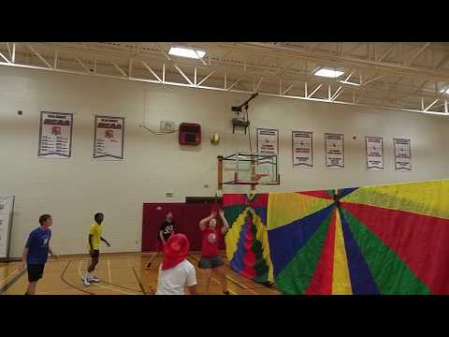

Fundamental Movement Skills:
- Manipulative Send
  - Strike

Equipment List:
- One Volleyball
- One Volleyball net
- One tarp or parachute... to cover the net.

Setting Up:
- Place six-nine players on each side of a volleyball net.
- Give one player the ball to serve it over the net to begin play.

Instructions:
- The player with the ball (move the player back if too easy to hit over the net or move this player forward if it is too difficult for this player to hit the ball over the net) hits the ball over the net.
- Each side can contact the ball a maximum of three times per side before the ball must go over the net.
- No player may strike the ball two times in a row.
- No player may hit the ball down over the net (no spiking).
- If the ball hits the floor the other team scores a point and gets the service.
- If the ball lands outsider the court that side scores a point and gets the service.

Notes and Questions for Understanding:
- Purpose:
  - To line up properly for sets and forearm passes.
  - To anticipate where ball is coming from and align defense accordingly.
- Questions for understanding:
  - Offensively, what are the best tactics to make it difficult for the defense to return the ball?
  - Defensively, what are the best tactics to be able to receive the ball most effectively?

