Physically Active Numeracy: Add Sum Fun
Dr. John Byl
Want More?
John Byl JOHNBYL50@gmail.com
www.canadago4sport.com
www.gophersport.com
Twitter & Instagram => @canadago4sport (for weekly posting of a new game)

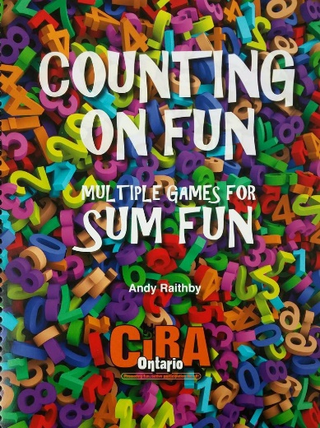
Description: Learning Math through Physical Activity and Learning Physical Activity through Math. Participate in active games that involve both mathematics and physical activity. Working your mind as we work the body. Learning to be more mathematically and physically literate. Some equipment used in session to be given to attendees.
Great resource:
https://www.ciraontario.com/countingonfun
Workshop Objectives:
- Learn and experience the integration of mathematics with physical activity.
- Lear the importance and simplicity of using physical activity in a classroom setting.
- Learn about safety considerations for physical activity in a classroom setting.
- Learn about helping the whole child learn through their whole being.

Workshop Agenda:

- In threes
  - 0-5... Relay Numbered Topple Tubes
  - Get to 101-104 Numbered Topple Tubes

- Opening
  - RPS Intro
    - https://www.canadago4sport.com/Warmups/Rock-Paper-Scissors-Four-Corner-Introductions
  - Geometric Shapes Gathered from a Square 4 cones and puzzle pieces
    - https://www.canadago4sport.com/Numeracy/Geometric-Shapes-Gathered-from-a-Square

- In twos
  - Ready Set Shoot (add, multiply, subtract plus, subtract negative)
    - https://www.canadago4sport.com/Numeracy/Ready-Set-Shoot-
  - True/False math…
    - https://www.canadago4sport.com/Numeracy/True-and-False
  - Dice Tag
    - Odd/Even 2 Large Die (and 1 small dice per player)
1 half pool noodle per player
    - https://www.canadago4sport.com/Numeracy/Dice-Tag%E2%80%94Odd-or-Even
    - Add
    - Multiply
    - South Pole (Plus)
- In threes
  - Paint Palette Relay 6 rainbow beanbags per team
    - https://www.canadago4sport.com/Numeracy/Paint-Pallette-Relay
- In twos
  - Planks till odd—grab bean bag for a point 1 Bean Bag per 2 players
    - https://www.canadago4sport.com/Numeracy/Paint-Pallette-Relay

- In sixes
  - Stryke’N Bowl Six Toppletubes plus 4 foam balls
    - In order first to 12 pins knocked over
    - https://www.canadago4sport.com/Numeracy/StrykeN-the-Pins
    - In order first to pass 50 points
    - https://www.canadago4sport.com/Numeracy/StrykeN-the-Pins-to-Over-50
    - In order first to exactly 30
    - https://www.canadago4sport.com/Numeracy/StrykeN-the-Pins-to-Exactly-40
  - Tic Tac Toe Toppletubes
    - https://www.canadago4sport.com/Numeracy/Tic-Tac-Toe%E2%80%94No-Grid-
    - Tic Tac Toe in push up Toppletubes
    - https://www.canadago4sport.com/Numeracy/Tic-Tac-Toe%E2%80%94No-Grid-With-Push-Up
    - Tic Tac Toe with run Toppletubes
    - https://www.canadago4sport.com/Numeracy/Tic-Tac-Toe%E2%80%94No-Grid-Relay
    - Topple Tic Tac--Double
    - https://www.canadago4sport.com/Numeracy/Topple-Tic-Tac
  - Relay make a math word—quick math Deck of cards & pool noodles (SUM)
    - https://www.canadago4sport.com/Numeracy/Quick-Count-Relay
  - Find Your Number 10 numbered cones and deck of cards
    - https://www.canadago4sport.com/Numeracy/Find-Your-Number-Relay
  - Ten Finger Fling—in groups with exercise 1 Decks of cards (1-10 with win take a (one hop, two hop, lunge with number) break and lose do 5 squats)
    - https://www.canadago4sport.com/Numeracy/Ten-Finger-Fling

- Larger groups or all
  - Heel-Toe Tag with correct is not It 3 playing cards per player
5 noodles per five players
    - https://www.canadago4sport.com/Numeracy/Heel-Toe-Tag
    - Add
    - https://www.canadago4sport.com/Numeracy/Tag-and-Add
    - Multiply
    - https://www.canadago4sport.com/Numeracy/Tag-and-Multiply
    - Divide
    - https://www.canadago4sport.com/Numeracy/Tag-and-Divide
  - Ping Pong 7
    - https://www.canadago4sport.com/Numeracy/Ping-Pong-7
  - Zero In—Number between 0-100 (5 Jacks-/+5 Squats)

Item |  | Details | Quantity | Subtotal
Big Foam Dice - Blue Pair  Item No: 10-022  Availability: In Stock | Price:  Unit: | C$30.00  Pr | 1 | C$30.00
Numbered Vinyl Cones - Numbered Vinyl Cones  Item No: 93-130  Availability: In Stock | Price:  Unit: | C$125.00  Set of 10 | 1 | C$125.00
Pool Noodles - Pool Noodles  Item No: 86-637  Availability: In Stock | Price:  Unit: | C$125.00  Set of 32 | 1 | C$125.00
ACTION! ToppleTubes Set - ACTION! ToppleTubes Set  Item No: 58-259  Availability: In Stock | Price:  Unit: | C$249.00  Set | 1 | C$249.00
Rainbow Beanbag Bonanza Packs - Cotton  Item No: 20-553  Availability: In Stock | Price:  Unit: | C$189.00  Pack of 96 | 1 | C$189.00
PEmoji Coated-Foam Balls - PEmoji Coated-Foam Balls  Item No: 72-094  Availability: In Stock | Price:  Unit: | C$115.00  Set of 6 | 1 | C$115.00

Bring from home
- 48 dice
- 2 decks of cards
- Felt marker
- Paint Palette slips

