Target Games with Innovative Equipment
Andy Raithby
Want More?
JOHNBYL50@gmail.com
www.canadago4sport.com
www.gophersport.com
Twitter and Instagram => @canadago4sport (for weekly posting of a new game)

Description: Using innovative equipment to learn Target Games. Using the Teaching Games for Understanding model, come and engage in innovative games that build skills and concepts of Target games. Opportunity will be given to do some peer leading. Come prepared to actively participate.
- Target Tactics and Strategies
  - Offensive
    - Aim and accuracy are the main focus
    - Get the object as close to the target as possible
    - Control the object’s speed and path to the target
    - Use spin and speed to avoid obstacles in your path to the target
  - Defensive
    - Block your opponent’s path to the target
    - Get your object closer to the target than your opponent
    - Knock your opponent’s objects away from the target
  - Transferable Skills
    - Most target games require a high degree of coordination of body parts
    - Players aim for accuracy
    - Objects are thrown, rolled or propelled at the target, requiring use of multiple body parts
    - A lot of transferable thinking strategies and adjustments are made throughout the game
    - Fine motor skills are needed to make changes to the path and speed of the object

- For a great book on target games go to:
https://www.ciraontario.com/product-page/target-games
Workshop Agenda
- Introduction (3 minutes)
- Warm up--Hoops toss and flip with frogs (4 Minutes)
- Each section is 5 minutes long—Groups switch sides (10 x 5 minutes = 50 minutes)
If about 10-20 participants
Competitors--try 1 each time  Triple toss  Two Square with spot  Baggo bean bag  Big Top Buketz  Big Top Frog Fling | Do as a half group  Frog Fling  Team Thin Pin Guard  Safe or Dare Thin Pin Guard  Stickit—take off opponents  Stickit—toss on opponents  Hula Hoop Horseshoes

If about 20-40 participants
Competitors--try 1 each time  Triple toss  Two Square with spot  Baggo bean bag  Big Top Buketz  Big Top Frog Fling | 1/9/2 Frog Fling  4/3/5 Team Thin Pin Guard  7/6/8 Safe or Dare Thin Pin Guard | 2/1/3 Stickit—take off opponents  5/4/6 Stickit—toss on opponents  8/7/9 Hula Hoop Horseshoes

Debrief (3 minutes)

Game descriptions and Videos

- Frog Fling
  - https://www.canadago4sport.com/Target1/Frog-Fling
- Team Thin Pin Guard
  - https://www.canadago4sport.com/Target1/Team-Thin-Pin-Guard
- Safe or Dare Thin Pin Guard
  - https://www.canadago4sport.com/Target1/Safe-or-Dare-Team-Pin-Guard
- Stick it Off
  - https://www.canadago4sport.com/Target1/Safe-or-Dare-Team-Pin-Guard
- Stick it On
  - https://www.canadago4sport.com/Target1/StickIt-On

- Hula Hoop Horseshoes
  - https://www.canadago4sport.com/Target1/Hula-Hoop-Horseshoes
- Triple Toss
  - https://www.canadago4sport.com/Target1/Triple-Toss
- Two Square with spot
  - https://www.canadago4sport.com/Target1/Ace-Chase-Two-Square
- Baggo
  - https://www.canadago4sport.com/Target1/Baggo-Bean-Toss
- Bit Top
  - https://www.canadago4sport.com/Target1/Big-Top-Bucketz
- Frog Fling Into Big Top
  - https://www.canadago4sport.com/Target1/Frog-Fling-into-Big-Top-Bucketz

Dear John Byl,
John Byl at has sent you their Gopher Sport shopping cart, as seen below:
 | Item |  | Details | Quantity | Subtotal
 | Baggo Beanbag Game - Baggo Beanbag Game  Item No: 41-884  Availability: In Stock | Price:  Unit: | C$139.00  Set | 1 | C$139.00
 | Rainbow BigTop Bucketz - Rainbow BigTop Bucketz  Item No: 58-288  Availability: In Stock | Price:  Unit: | C$125.00  Set | 1 | C$125.00
 | ACTION! StickIt Set - ACTION! StickIt Set  Item No: 58-660  Availability: In Stock | Price:  Unit: | C$375.00  Set | 1 | C$375.00
 | ACTION! FrogFling Set - ACTION! FrogFling Set  Item No: 58-684  Availability: In Stock | Price:  Unit: | C$415.00  Set | 1 | C$415.00
 | DuraHoop - Set of 12, 30" dia  Item No: 43-505  Availability: In Stock | Price:  Unit: | C$85.00  Set of 12 | 1 | C$85.00
 | Heavyweight Vinyl Cones - Set of 6, 6"H  Item No: 93-069  Availability: In Stock | Price:  Unit: | C$69.00  Set of 6 | 1 | C$69.00
 | GamePlay TripleToss Set - GamePlay TripleToss Set  Item No: 58-310  Availability: In Stock | Price:  Unit: | C$115.00  Set | 2 | C$230.00
 | Rainbow TopSpot Vinyl Spots - Rainbow Set, 5" dia  Item No: 93-022  Availability: In Stock | Price:  Unit: | C$25.00  Set of 6 | 1 | C$25.00

Big Top Bucketz
Objective: Be the first team to toss a beanbag into all three bucketz.
Equipment at: https://www.gophersport.com/pe/activities/rainbow-bigtop-bucketz
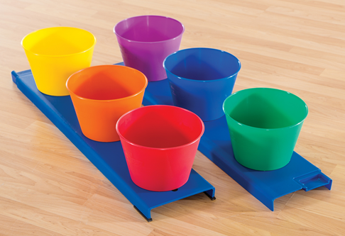
Setup:
- Two teams of three stand behind a tossing line.
- Each team has three Big Top Bucketz about 3-5 paces away (closer is easier; further is more difficult)

Instructions:

- On the signal to begin the first player attempts to throw a bean bag into one of their bucketz.
  - If successful this player goes to the back of their line and the next player attempts to throw a bean bag into one of the bucketz.
  - If unsuccessful (either by missing a bucketz or tossing it in a bucketz with an existing bean bag) that player retrieves their bean bag and either runs back with it to the end of the line, or if there are one or more bean bags already in the bucketz, tosses the beanbag to the next person that is need of a bean bag.
- First team to get all three beanbags into each of the bucketz is the winner.
- Play again.
Questions for Understanding:
- What are tips for tossing accurately?

Big Top Bucketz--21
Objective: Be the first team to score 21 points.
Equipment at: https://www.gophersport.com/pe/activities/rainbow-bigtop-bucketz
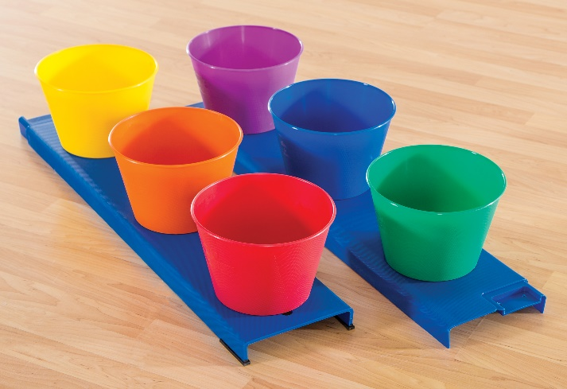
Setup:
- Two teams of three stand behind a tossing line.
- Each team has three Big Top Bucketz about 3-5 paces away (closer is easier; further is more difficult)

Instructions:
- On the signal to begin the first player attempts to throw a bean bag into one of their bucketz.
  - If successful:
    - Scores are added up.
      - One point for nearest bucketz
      - Two points for second bucketz
      - Three points for furthest bucketz
    - This player retrieves their bean bag.
  - If unsuccessful (by missing a bucketz) that player retrieves their bean bag.
  - Player returns to the back of the line and the next player tosses their bean bag.
- First team to score 21 points is the winner (if a team scores over 21 they subtract the last throw (if a team has 20 points and scores a 2, they are over and therefore subtract 2, giving them 18 points).
- Play again.
Questions for Understanding:
- What are tips for tossing accurately?

Triple Toss

Objective: Be the first team to score exactly 21 points.
Equipment: https://www.gophersport.com/pe/activities/gameplay-tripletoss
- Two targets (1 ea red, blue, 24”L x 24”W x 36”H each)
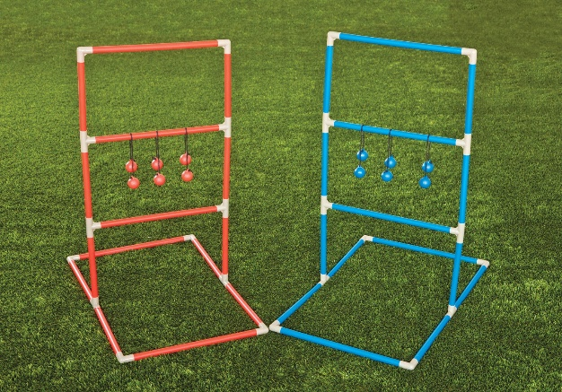
- Six bolos (3 ea red, blue),
Setup:
- Set up the targets five paces apart from each other.
- Pairs of players stand at either target and compete against another pair standing at either target.
Instructions:
- Determine who throws first (after the first set of throws the team that scores the most the last set of throws is the team that throws first).
- Teams alternate throws.
- Points are scored as follows:
- Three points if the bolos wraps around the top bar.
- Two points if the bolob wraps around the middle bar.
- One point if the bolos wraps around the bottom bar.
- If a team scores more than 21 their score drops to 15.
Questions for Understanding:
- What are tips for tossing accurately?

Bacco Bean Toss
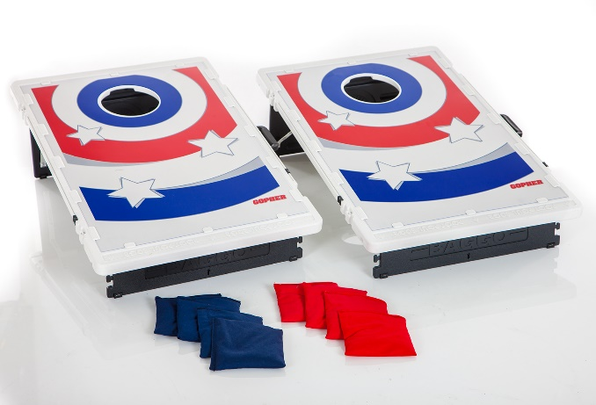
Objective: Be the first team to score 31 points.
Equipment at: https://www.gophersport.com/pe/beanbags/baggo-beanbag-game
Equipment:
- 2 boards (33-1/2”L x 20”W)
- 8 beanbags (4 Ea Red, Blue)
- 20’L measuring cord
- A wall mount.
Setup:
- Place the two boards 20 feet (7 paces) apart
- Pairs of players stand behind either board and compete against another pair standing at either board.

Instructions:

- Determine who throws first (after the first set of throws the team that scores the most the last set of throws is the team that throws first).
- Teams alternate throws.
- Points are scored as follows (mostly in):
  - 1 point on the white for each one closest to the hole.
  - 2 points for going into the hole.
Questions for Understanding:
- What are tips for tossing accurately?

